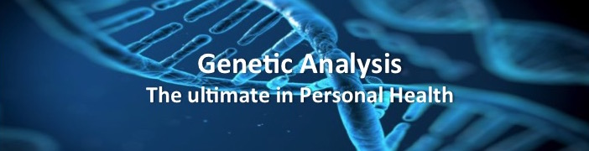
Our bodies are controlled by a set of genetic instructions known as our genome or chromosomal blueprint. Our individual DNA provides codes for everything from eye colour to antibody production; It determines our risk for disease, our reaction to stress, our response to illness or injury and how we respond to food, exercise and medication. For example, 70% of our metabolism and body weight is controlled by our genetic coding. This allows us to see why some people respond well to high-protein low-carb diets, while for others it is inefficacious or actually increases weight. Genetics also explains why curcumin or turmeric increases inflammation in some people and decreases it in others. What fits your body best is all coded in your DNA.
While we can’t change our genes, we can change the strength with which they express their traits. This can be achieved through natural supplements, diet, exercise and other lifestyle variables. Decoding your genetic data provides you with a detailed blueprint of how your body works. It allows your doctor to advise you of your specific health risks and your reaction to factors such as foods, exercise and stress. And it provides the foundation for a highly individualized lifestyle and treatment protocol.
What will you get from your genetic report
An analysis and treatment plan for the following:
Metabolism: How often you should eat and how that affects your weight. What controls your metabolism, food cravings and hunger. What is your best diet? Is Intermittent Fasting right for you?
Dietary: Response and handling of dietary carbohydrates, fats, proteins and dairy, with the exact amount of each macro nutrient you require to manage weight, balance blood sugar levels and prevent disease.
Exercise and Cardiovascular Health: What type of cardiovascular and resistance training is best for you with respect to oxygenation, inflammation, recovery, cardiovascular and metabolic health.
Neurotransmitters and Hormones: An in-depth look at production, transportation, binding and receptor density of dopamine, serotonin, cortisol, adrenaline, noradrenaline, CRH, ACTH, estrogen and testosterone and their impact on associated disorders.
Immunity: A look at immune response to determine your risk and how to better manage allergies, infections, auto-immune disorders and inflammatory disease.
Inflammation: Examines the production of inflammatory mediators that contribute to disease risk and progression.
Detoxification: A look at detoxification pathways in the body to help identify, modify and clear toxins, hormones and medications.
Sleep: A look at circadian rhythms, the ability to transition from one stage of sleep to the next, the time spent in deep stage 4 sleep, and strength of the wake/sleep cycle.

